Lab 2

Tony Sommer

In this lab I made a simple jQuery Mobile app that uses the Google Maps web service. In this app there are two buttons, one says Kansas City, the other says St. Louis.

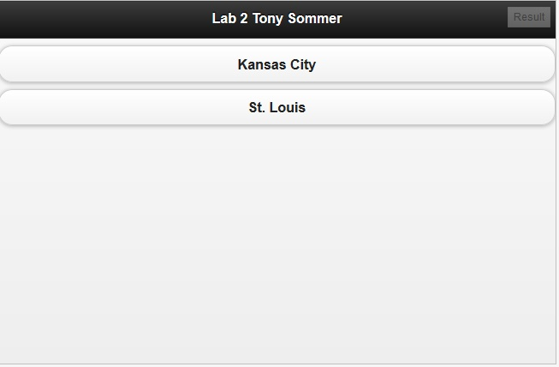

When you click Kansas City it pop ups a map centered on Kansas City, and the same for St. Louis. Or, at least it should…

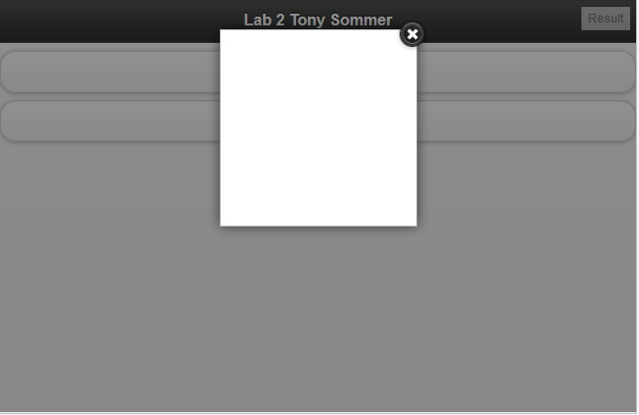

I’m not quite sure why the maps aren’t working. I think it may be a problem with JSFiddle (which I used for the screen shots) and how it uses the jQuery Mobile, because when I stripped away the jQuery Mobile aspects and just had it displaying the maps to a div, it worked perfectly.

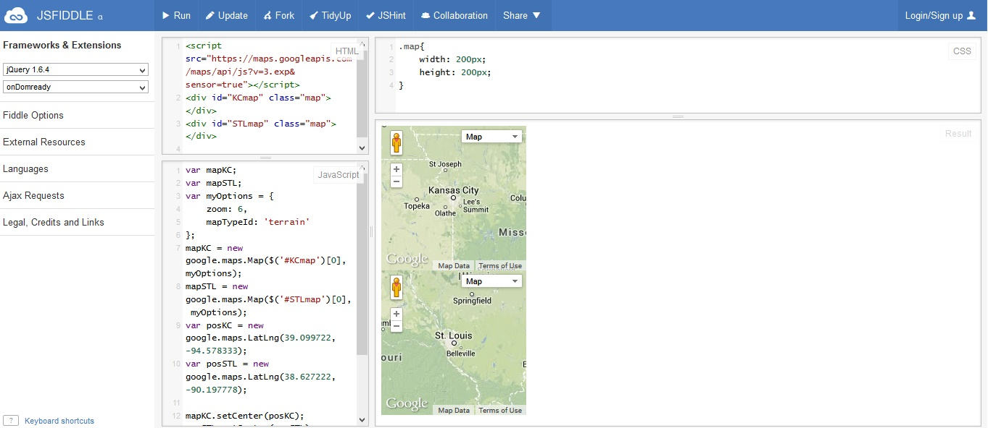

The top map is centered on Kansas City, while the bottom map is centered on St. Louis. The only difference between these two applications is the removal of some div’s around the map. The JavaScript is exactly the same.